|  |
| --- |
| Experiment - 3 |

* **Title**: Formulas in MS Excel.
* **SUMIF**: This function adds up values in a range that meet specified criteria. For example, you could use SUMIF to add up all sales amounts where the product is "Apple".

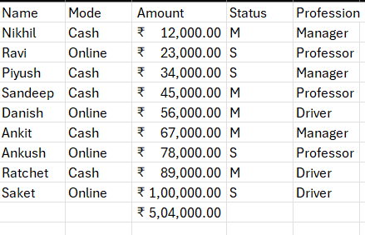

* **COUNTIF**: This function counts the number of cells within a range that meet the given criteria. For instance, you could use COUNTIF to count the number of times "Done" appears in a list of tasks.

|  |  |
| --- | --- |
|  |  |

* **SUMIFS**: Similar to SUMIF, but allows for multiple criteria. It adds up values in a range based on multiple conditions. For example, you could use SUMIFS to add up all sales amounts where the segment is "Consumer" and the Ship Mode is "Second Class".

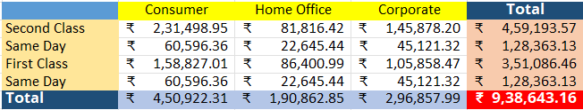

* **COUNTIFS**: Similar to COUNTIF, but allows for multiple criteria. It counts the number of cells within a range that meet multiple conditions. For instance, you could use COUNTIFS to count the number of times "Done" appears in a list of tasks assigned to a particular person.

* **VLOOKUP**: Stands for Vertical Lookup. It searches for a value in the first column of a table and returns a value in the same row from a specified column. The syntax is `VLOOKUP(lookup_value, table_array, col_index_num, [range_lookup])`. For example, `=VLOOKUP(A2, B:C, 2, FALSE)` looks for the value in cell A2 in column B, and returns the corresponding value from column C.

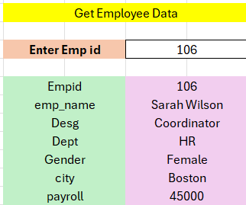 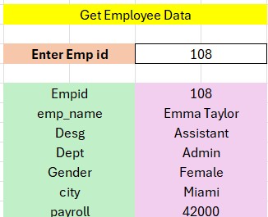

* **HLOOKUP**: Stands for Horizontal Lookup. It works similar to VLOOKUP, but searches for a value in the first row of a table and returns a value in the same column from a specified row. The syntax is `HLOOKUP(lookup_value, table_array, row_index_num, [range_lookup])`.

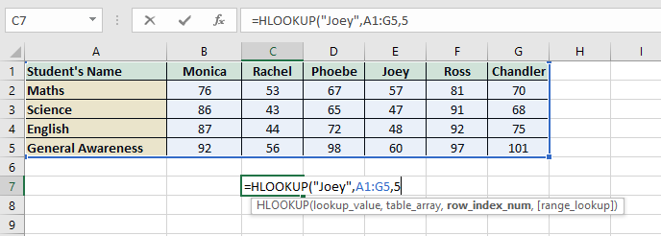

* **MATCH**: It returns the relative position of an item in a range. The syntax is `MATCH(lookup_value, lookup_array, [match_type])`. For example, `=MATCH(A1, B1:B10, 0)` searches for the value in A1 within the range B1:B10 and returns the position of the value in the range.

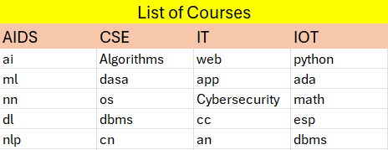 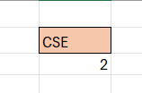

* **ROW**: It returns the row number of a reference. The syntax is `ROW([reference])`. For example, `=ROW(A1)` returns the row number of cell A1.
* **INDEX**: It returns the value of a cell in a specified row and column of a table or range. The syntax is `INDEX(array, row_num, [column_num])`. For example, `=INDEX(A3:D7, 0,2))` returns the value in the all rows and second column of the range A3:D7.

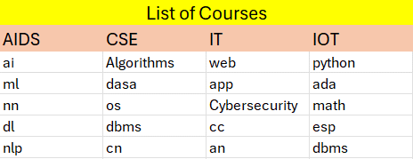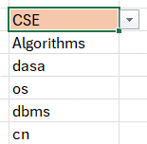

These functions are commonly used in Excel for looking up values, finding positions, and retrieving data from tables or ranges.